1.Look and write

cucumber onion lemon melon meat cereal
noodles mushrooms pastry garlic bean sprouts sauce

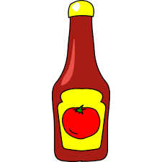 | 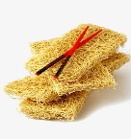 | 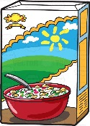 | 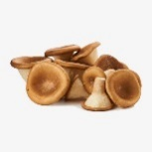
………………………. | ………………………. | ………………………. | ……………………….
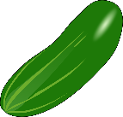 | 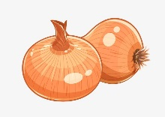 | 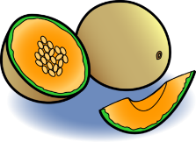 | 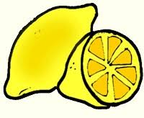
………………………. | ………………………. | ………………………. | ……………………….
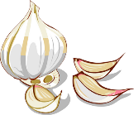 | 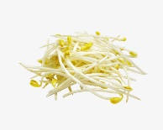 |  | 
………………………. | ………………………. | ………………………. | ……………………….

2. Put the words in the correct column
bean sprouts mushrooms egg milk tomato fruit bread juice tea chocolate
cereal apple lemon meat rice potato carrot grapes oil cucumber
sugar onion coffee tea cheese garlic plum water orange melon

Countable | Uncountable
…………………………………………………..  …………………………………………………..  …………………………………………………..  …………………………………………………..  …………………………………………………..  ………………………………………………….. | …………………………………………………..  …………………………………………………..  …………………………………………………..  …………………………………………………..  …………………………………………………..  …………………………………………………..

3. Look, write the food words with a , an or some.
tomatoes salad cake cheese strawberries crisps
pineapple lemonade sugar carrots mango juice egg

Sue has some tomatoes, some salad  , a cake……………………………  ……………………………………….  ……………………………………….  ……………………………………….  ……………………………………….. | 